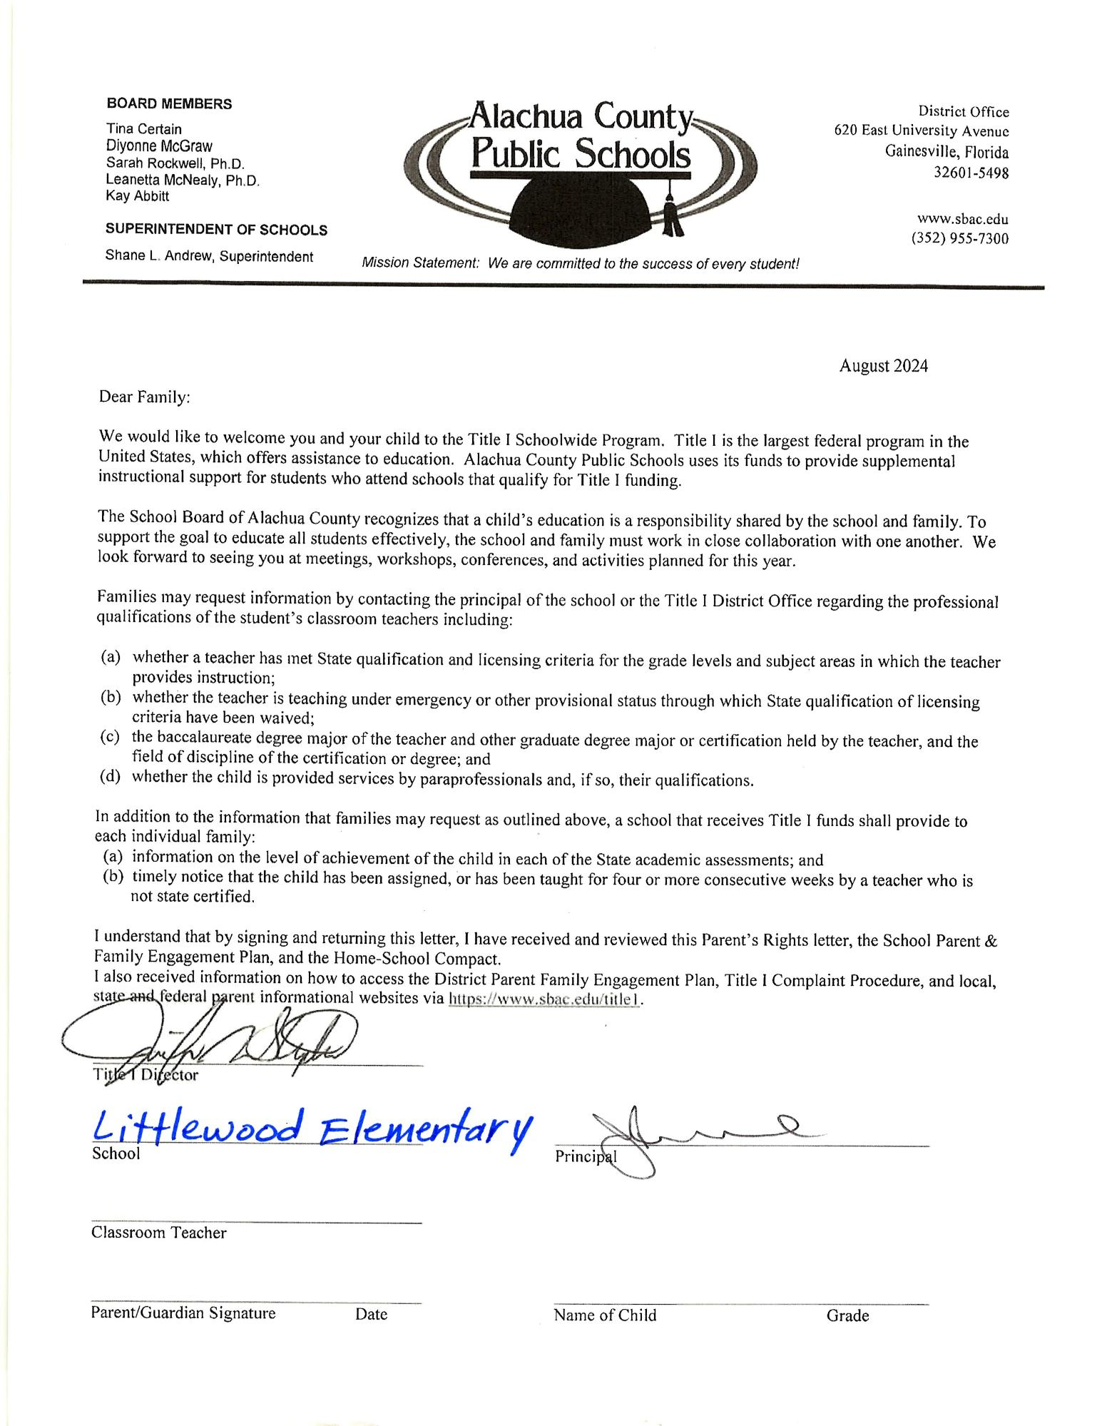

**BOARD MEMBERS**

Tina Certain

Diyonne McGraw

Sarah Rockwell, Ph.D.

Leanetta McNealy, Ph.D. Kay Abbitt

**SUPERINTENDENT OF SCHOOLS**

Shane L. Andrew, Superintendent

**Alachua County Public Schools**

District Office

620 East University Avenue Gainesville, Florida

32601-5498

www.sbac.edu

(352) 955-7300

*Mission Statement: We are committed to the success of every student!*

August 2024

Dear Family:

We would like to welcome you and your child to the Title I Schoolwide Program. Title I is the largest federal program in the United States, which offers assistance to education. Alachua County Public Schools uses its funds to provide supplemental instructional support for students who attend schools that qualify for Title I funding.

The School Board of Alachua County recognizes that a child's education is a responsibility shared by the school and family. To support the goal to educate all students effectively, the school and family must work in close collaboration with one another. We look forward to seeing you at meetings, workshops, conferences, and activities planned for this year.

Families may request information by contacting the principal of the school or the Title I District Office regarding the professional qualifications of the student's classroom teachers including:

(a) whether a teacher has met State qualification and licensing criteria for the grade levels and subject areas in which the teacher provides instruction;

(b) whether the teacher is teaching under emergency or other provisional status through which State qualification of licensing criteria have been waived;

(c) the baccalaureate degree major of the teacher and other graduate degree major or certification held by the teacher, and the field of discipline of the certification or degree; and

(d) whether the child is provided services by paraprofessionals and, if so, their qualifications.

In addition to the information that families may request as outlined above, a school that receives Title I funds shall provide to each individual family:

(a) information on the level of achievement of the child in each of the State academic assessments; and

(b) timely notice that the child has been assigned, or has been taught for four or more consecutive weeks by a teacher who is not state certified.

I understand that by signing and returning this letter, I have received and reviewed this Parent's Rights letter, the School Parent & Family Engagement Plan, and the Home-School Compact.

I also received information on how to access the District Parent Family Engagement Plan, Title I Complaint Procedure, and local, state and federal parent informational websites via https://www.sbac.edu/titlel.

Title Director

Littlewood Elementary

School

Classroom Teacher

Principal

Parent/Guardian Signature

Date

Name of Child

Grade