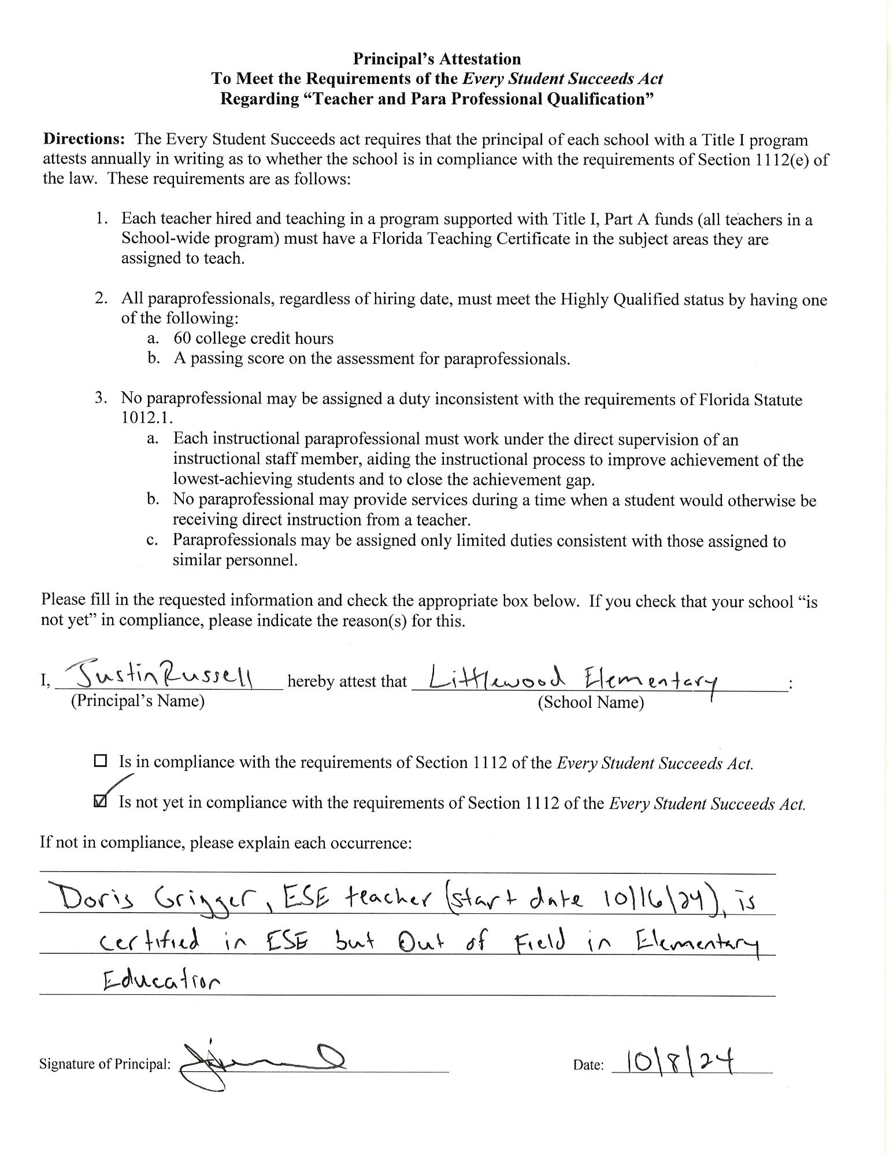

**Principal's Attestation**

***To Meet the Requirements of the Every Student Succeeds Act***

**Regarding "Teacher and Para Professional Qualification"**

Directions: The Every Student Succeeds act requires that the principal of each school with a Title I program attests annually in writing as to whether the school is in compliance with the requirements of Section 1112(e) of the law. These requirements are as follows:

1. Each teacher hired and teaching in a program supported with Title I, Part A funds (all teachers in a School-wide program) must have a Florida Teaching Certificate in the subject areas they are assigned to teach.

2. All paraprofessionals, regardless of hiring date, must meet the Highly Qualified status by having one of the following:

a. 60 college credit hours

b. A passing score on the assessment for paraprofessionals.

3. No paraprofessional may be assigned a duty inconsistent with the requirements of Florida Statute

1012.1.

a. Each instructional paraprofessional must work under the direct supervision of an instructional staff member, aiding the instructional process to improve achievement of the lowest-achieving students and to close the achievement gap.

b. No paraprofessional may provide services during a time when a student would otherwise be receiving direct instruction from a teacher.

c. Paraprofessionals may be assigned only limited duties consistent with those assigned to similar personnel.

Please fill in the requested information and check the appropriate box below. If you check that your school "is not yet" in compliance, please indicate the reason(s) for this.

I,

Justin Russell

(Principal's Name)

hereby attest that Littlewood Elementary

(School Name)

*Is in compliance with the requirements of Section 1112 of the Every Student Succeeds Act.*

Is not yet in compliance with the requirements of Section 1112 of the Every Student Succeeds Act.

If not in compliance, please explain each occurrence:

Doris Grigger, ESE teacher (start date 10/16/24), is certified in ESE but Out of Field in Elementary Education

Signature of Principal:

Date:

10/8/24